Docking Station Instructions

Connect the USB-C Cable to your device as shown in the diagram below.

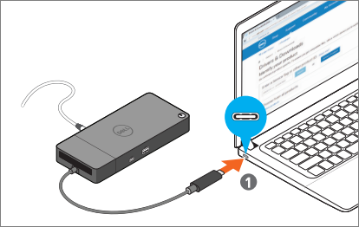

The USB-C Cable will provide power to your device, as well as allow you to use the screen, keyboard, and mouse.

If your device will not recognize the dock, you may need to press the power button on the dock, which is on the top right side of the docking station.

